EXPT NO:5 | DEVELOP INTERACTIVE DASHBOARDS FOR DYNAMIC DATA EXPLORATION USING TABLEAU AND POWERBI
DATE: 24.07.2026

PRE-LAB QUESTIONS (PROVIDE BRIEF ANSWERS TO THE FOLLOWING QUESTIONS)

- What is dynamic data exploration in BI tools, and why is it important?

Dynamic data exploration means allowing users to interact with the data and explore it from different perspectives. In our COVID-19 dashboard, users can select a country, location, or date range to view specific case, death, and vaccination information. It is important because it helps users quickly find trends and insights without creating separate reports.

- What are slicers and filters, and how do they enhance dashboard interactivity?

Slicers in Power BI and filters in Tableau are tools used to select specific data for analysis. For example, users can filter the COVID-19 dashboard by country or date range. They enhance interactivity by automatically updating charts, maps, and KPI cards based on the user's selection.

- How do Tableau and Power BI support drill-down and drill-through features?

Drill-down allows users to move from a higher-level view to more detailed data. For example, in a COVID-19 report, users can go from Year → Month → Day. Drill-through allows users to select a particular country and open another report page containing detailed information about that country. These features help users analyze data at different levels of detail.

- What is the role of parameters in creating interactive dashboards?

Parameters allow users to dynamically change the way data is displayed or analyzed. For example, a parameter can allow users to choose between Total Cases, Total Deaths, or Vaccination Coverage in a visualization. This makes the dashboard more flexible and interactive.

- Name some advanced interactivity features in Tableau and Power BI.

Some advanced interactivity features are drill-down, drill-through, parameters, filters, slicers, tooltips, cross-filtering, highlighting, dashboard actions, bookmarks, and interactive maps. These features allow users to explore data in more detail and get useful insights from the dashboard.

IN-LAB EXERCISE:
OBJECTIVE:
To design and develop interactive dashboards in Tableau and Power BI for dynamic data exploration, enabling users to analyze, filter, and drill down into data for deeper insights.

PROCEDURE:
- Data Collection:
  - Import datasets from sources such as Excel, CSV, SQL Server, or online APIs.
  - Dataset: Retail Sales Dataset with fields such as Order Date, Region, Product Category, Sales, Profit, Quantity.
- Data Preparation and Transformation:
  - Ensure proper date formats for time-based analysis.
  - Handle missing or incorrect values.
  - Create calculated fields (e.g., Profit Margin %, Sales Growth %, Year-to-Date Sales).
- Data Aggregation and Hierarchies:
  - Create hierarchies (e.g., Year → Quarter → Month → Day).
  - Aggregate data by region, product category, or customer segment.
- Designing Interactive Elements:
  - Filters & Slicers: Allow filtering by product category, date range, or region.
  - Parameters: Let users switch between KPIs (e.g., Sales vs. Profit).
  - Drill-down: Enable users to explore data from summary to detail.
  - Tooltips: Add contextual details when hovering over data points.
- Dashboard Development:
  - Tableau: Use interactive filters, parameter controls, and highlight actions.
  - Power BI: Use slicers, bookmarks, and drill-through pages.
  - Add KPI cards for key metrics like Total Sales, Total Profit, Top Selling Product.
  - Use maps for regional sales analysis, line charts for trends, and bar charts for category comparisons.
- Testing Interactivity:
  - Ensure slicers and filters update all relevant visuals dynamically.
  - Test drill-down and drill-through functionality for accuracy.
- Publishing and Sharing:

  - Tableau: Publish on Tableau Public or Tableau Server.
  - Power BI: Publish to Power BI Service and share via workspace access or public link.
Experiment Dataset:
Retail Sales Dataset
Fields Used:
- Order Date – Date of the order
- Region – Sales region
- Product Category – Category of product sold
- Sales – Sales revenue
- Profit – Net profit from the order
- Quantity – Units sold

Power BI:

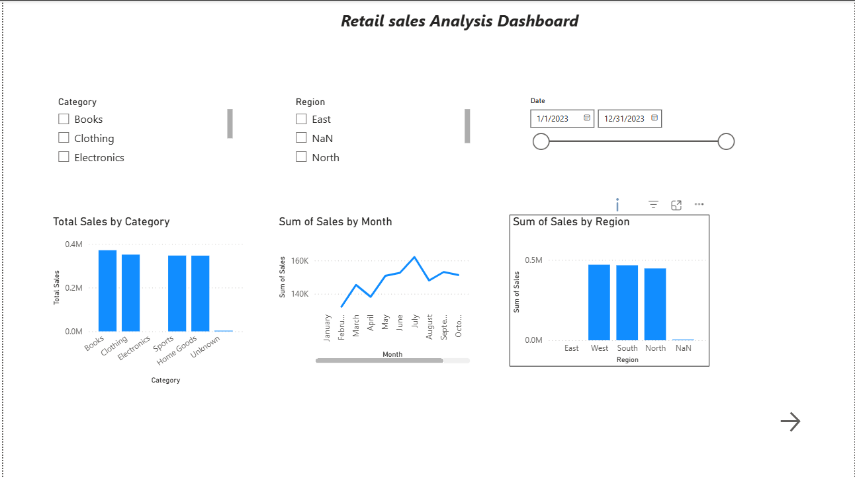

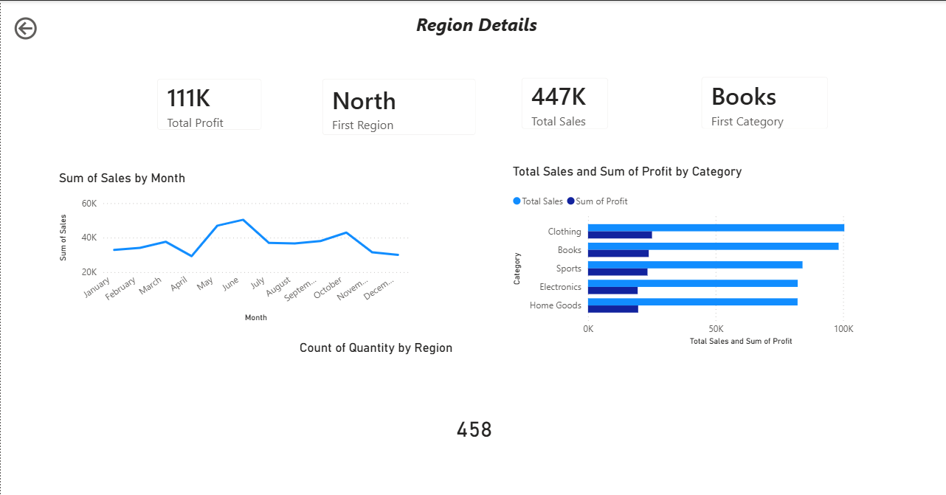

Tableau:

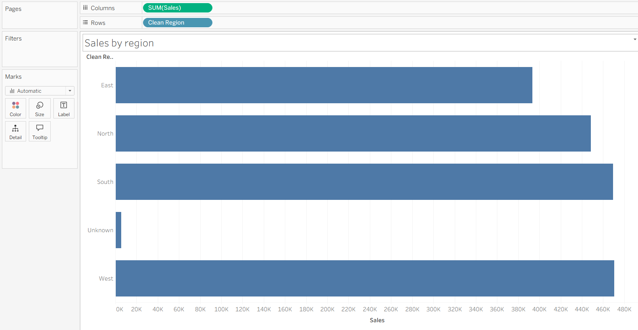

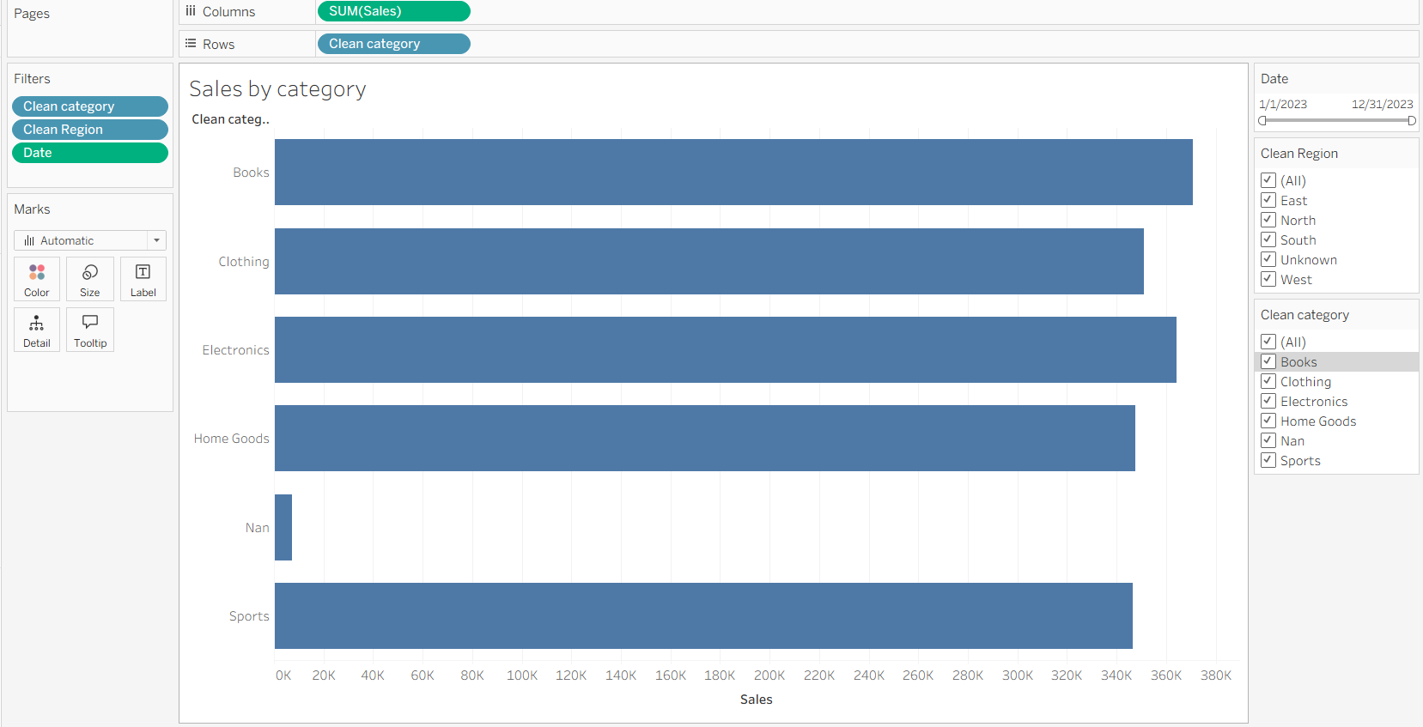

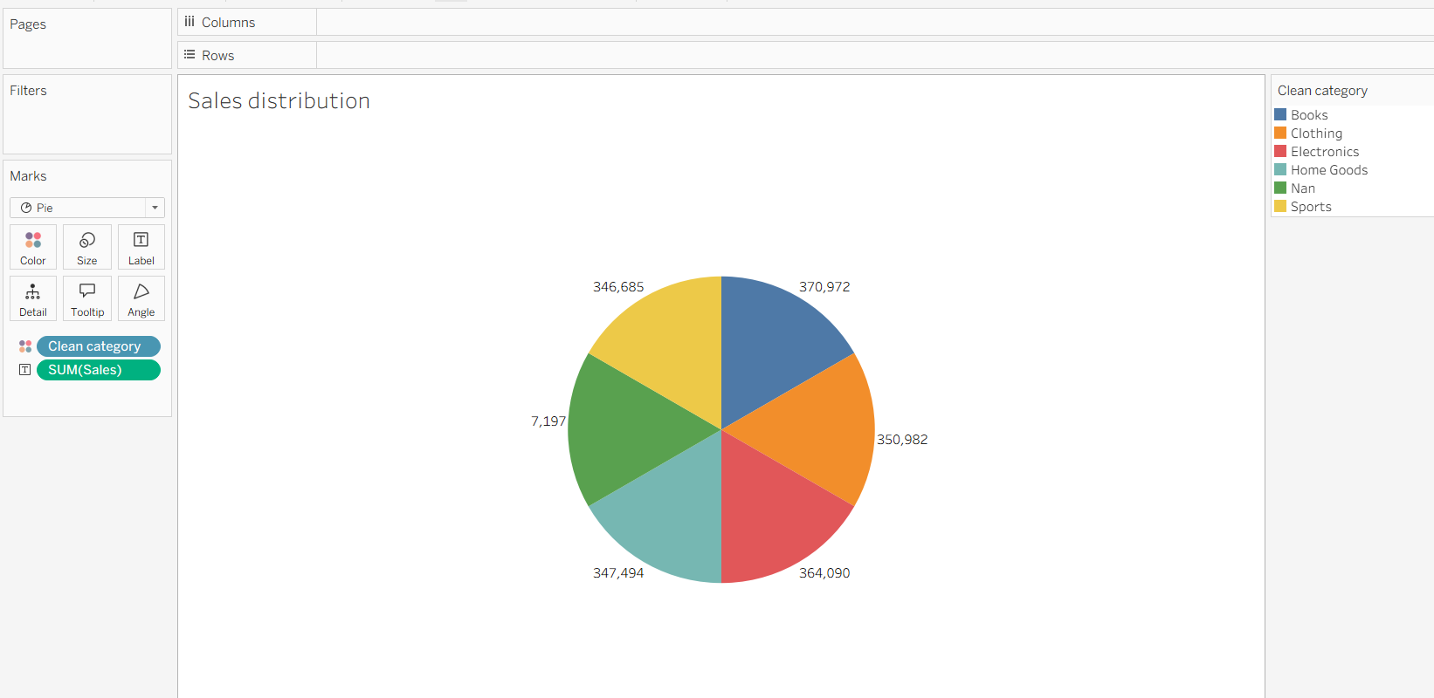

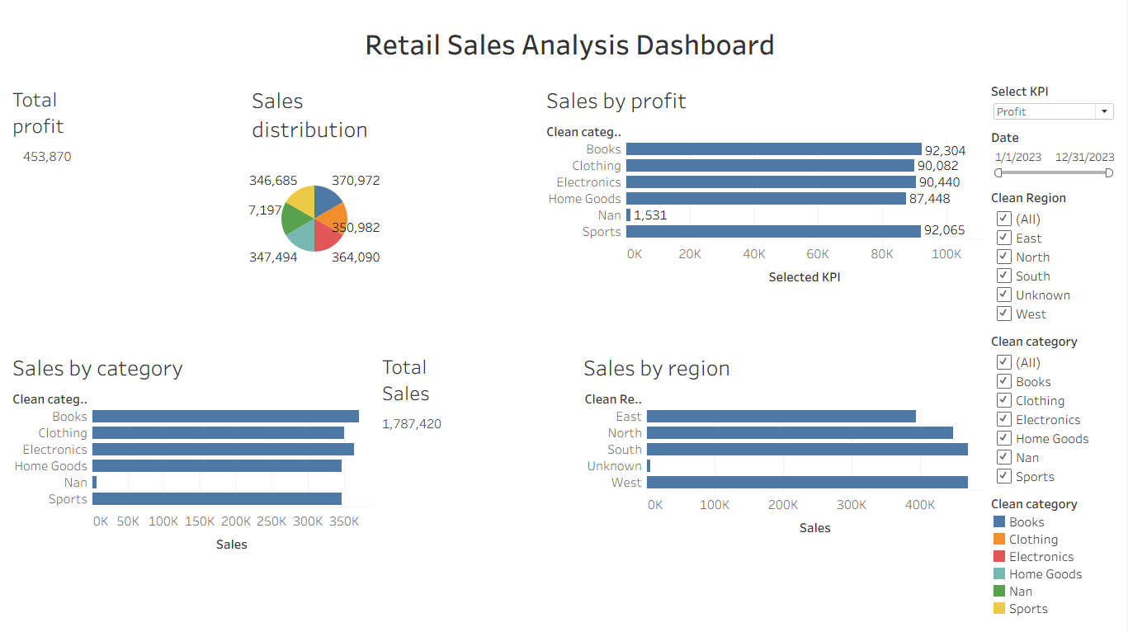

POST-LAB QUESTIONS (PROVIDE BRIEF ANSWERS TO THE FOLLOWING QUESTIONS)
- How did interactivity improve the analysis experience in your dashboard?
Interactivity made the dashboard easier to explore and understand. Users can select a region, product category, or date range and view the corresponding changes in sales and profit. It helped users quickly identify trends and compare different parts of the retail data.

- Which interactive feature (filters, drill-down, parameters, etc.) was most useful and why?

Filters and slicers were the most useful features because they allowed users to easily select a specific region, category, or date range. The dashboard visuals and KPI cards updated automatically, making it easier to analyze specific data.

- What challenges did you face while implementing drill-down or dynamic filters?

The main challenges were setting up the date hierarchy correctly and ensuring that filters affected all relevant visuals. Another challenge was configuring the drill-through page so that the selected region displayed only its detailed information. These issues were resolved by checking the field types, relationships, and filter settings

- How do tooltips contribute to better dashboard storytelling?

Tooltips provide additional information when the user hovers over a data point. For example, hovering over a chart can show sales, profit, quantity, or category details. This gives users more information without overcrowding the dashboard and helps them understand the data better.

- What additional features would you add to make the dashboard more insightful?

I would add more KPIs, year-over-year sales comparisons, profit margin analysis, advanced drill-through pages, dynamic parameters, and trend indicators. I would also add more detailed tooltips and allow users to compare different regions and product categories interactively.

RESULT:
The retail sales dataset was successfully transformed, aggregated, and visualized into interactive dashboards in Tableau and Power BI. Filters, slicers, drill-downs, and parameters enabled dynamic exploration of sales and profit trends by region, product category, and time period. The resulting dashboards allowed for quick insights and deeper analysis, enhancing decision-making capabilities.

ASSESSMENT

Description | Max Marks | Marks Awarded
Pre Lab Exercise | 5
In Lab Exercise | 10
Post Lab Exercise | 5
Viva | 10
Total | 30
Faculty Signature

